Western Australian Travel-Safe Interagency Group
Wheelchair Transportation Safety Checklist: Based on International Best Practice Guidelines and Australian Standards
Person’s Name: |  |  | Date of Birth:
Address: |  |  | Sex: M/F/O
Diagnosis: |  |  | Date of Assessment:
If prescribing equipment that is not compliant with Australian standards, a Risk assessment is to be completed as per AS ISO 14971:2020 Medical Devices – Application of Risk management to medical devices
References and recommended reading:
- AS/NZS 3696.19:2009 (Wheeled mobility devices for use as seats in motor vehicles (ISO 7176-19:2008, MOD))
- AS/NZS ISO 16840.4:2014 (Seating Systems for use in motor vehicles)
- AS/NZS 10542.1:2015 (Technical systems and aids for people with disability – Wheelchair tiedown and occupant-restraint systems: Requirements and test methods for all systems (ISO 10542.1, MOD))
- ISO 10542-1:2012/Amd 1:2021 (Technical systems and aids for disabled or handicapped persons - Wheelchair tiedown and occupant-restraint systems - Part 1: Requirements and test methods for all systems - Amendment 1: Annexes K, L, M)
- ISO 7176-19:2008 Wheelchairs – Part 19: Wheeled mobility devices for use as seats in motor vehicles
- International Best Practice Guidelines – BPG1 Transportation of People Seated in Wheelchairs: 1st Revision 2019 (Version 2.2 April 2020 Minor Update). Many photos used within this document have been taken from this document.
- Road Traffic Code 2000: Western Australian Legislation
- Decision Making Tree, Western Australian Travel-Safe Interagency Group, 2016.
“Transportation is only one of many daily activities that introduce unique circumstances and requirements that wheelchairs and wheelchair occupants may experience. Wheelchair products that comply with this part of ISO 7176 will have additional features that provide increased levels of occupant security and safety whilst their occupants are riding in motor vehicles. However, a wheelchair's failure to comply with this part of ISO 7176 cannot be used to limit access to, and availability of, motor vehicle transportation of wheelchair users."
(ISO 7176-19:2008/ANZS 3696.19:2009)
In the first instance when travelling in a motor vehicle, it is considered safest (from a Transportation safety perspective) for wheelchair occupants to transfer out of their wheelchair to a vehicle seat and to use the vehicle seatbelt system or child safety seat that complies with the appropriate state and national legislative requirements.

Is this a suitable option? (if “no” and/or the client is required for safety reasons to stay seated in their wheelchair for transportation: continue to complete form) YES NO
Wheelchair Suitability
To be considered when transfer to a seat in a motor vehicle is not possible or not feasible (e.g. safety or behavioural concerns).
Please circle and indicate appropriate response below:

Wheelchair: Model/Type: ________________________________ PWC / MWC / MWC with power assist

What is the weight of the occupied wheelchair?

________________________________kg +_____________________________kg =____________________ kg
(weight of wheelchair, plus components essential (weight of person) (total occupied weight)
for life and any body support system*)

* If unsure of weight of body support system, add 15kg for standard or 20kg for complex.
Please circle and indicate appropriate response below. Note: Any "No" responses may indicate a transport risk and risk of not meeting standards. Risks should be addressed as per the applicable risk assessment document of which your organisation uses prior to transportation and the person/NOK should be advised of the risks and these need to be documented in client’s notes. For any not applicable responses please state with reasons why.
Does the person’s body weight fall within the SWL of the wheelchair? (Refer to manufacturer’s manual/website for specifications.) | YES | NO
Has the wheelchair passed crash testing to ISO 7176-19:2008 and/or AS/NZ 3696.19?  (Ask for compliance certificate from the supplier or the manufacturer and document this in client’s notes.  Note that most wheelchairs are only crash tested up 136Kgs of SWL due to size of the dummy that is used in the automobile industry.  If the chair is not compliant to the above-mentioned standard, the clinical justification needs to clearly outline the reasons and documented in the notes. The manufacturer/ supplier needs to be consulted to get advice regarding the recommended tiedown points and lugs) | YES | NO
Does the wheelchair have transport lugs? OR | YES | NO
Are there designated points on the frame for tie downs? | YES | NO
Note: If the wheelchair is compliant to ISO 7176-19:2008 and/or AS/NZ 3696.19 standards: the designated tie down points should be clearly labelled by a carabiner symbol
Wheelchairs are regulated as medical devices in Australia. Has the device been registered as a medical device with the Therapeutic Goods Administration (TGA)?  Ask for the Australian Regulatory Therapeutic Goods (ARTG) certificate from the supplier or the manufacturer and document this in client’s notes. | YES | NO
Wheelchair Frame/Accessories
Is the frame free of visible damage or rust? | YES | NO
If this wheelchair has been involved in a motor vehicle accident has it been checked by a qualified technician or engineer for frame integrity? (To ensure it is structurally sound) | YES | NO
Is the upholstery in good condition/undamaged? | YES | NO
Are the tyres inflated correctly? (As per specifications on the tyre or recommendations written in the user manual) | YES | NO
Do the brakes engage and prevent the wheelchair from rolling with and without the user? | YES | NO
Is a headrest in situ on the wheelchair/insert for use during transportation?  The wheelchair is required to have a high backrest or head support securely fastened to wheelchair uprights or fitted firmly into backrest tubing, with any metal crossbar effectively padded (AS/NZS 3696.19:2009 Section 4.2.3 & ZA2) | YES | NO
Is the person able to hold their head up against a flat headrest, without additional support in place?  (If no, specify what type of head support required to meet their postural/medical needs).  Flat headrests are recommended for use during transportation to minimise risk of injury during a crash event (due to client’s head getting trapped in gaps on the way back or hitting parts of the headrest). However, a flat headrest may not be suitable for the client from a postural support perspective. | YES | NO
Is the backrest at or above person’s shoulder height? | YES | NO
Can wheelchair accessories that are non-essential for life be removed from wheelchair?  e.g. Trays, IV poles, switching, accessory/device mounting, communication devices should be removed (unless these are essential for life or wellbeing) and stored securely during travel.  Wheelchair hard trays are removed during vehicular transport and stored securely in the vehicle (AS/NZS 3696.19:2009 Section ZA6) | YES | NO
Has the postural support system (insert) been crash tested to ISO 16840 – 4:2014?  Ask for compliance certificate from the supplier or the manufacturer and document this in client’s notes.  If the device is a custom made/client matched device, check with the manufacturer/supplier that the specific device has been registered/reported with TGA (e.g. custom foam cushions, backrests, seating inserts made by Ability Tech, Posture Tech, Rehabilitation Engineering Clinic).  Ask for essential principles checklist, Risk assessment and proof of registering and reporting the device to TGA and document this in client’s notes. | YES | NO
Is the body support system (insert) secured to the wheelchair frame as per manufacturer’s instructions?  Specialised seating inserts (such as those made with wooden inserts or moulded thermoplastics) are required to be fastened securely to the wheelchair frame (AS/NZS 3696.19:2009 Section ZA2) | YES | NO
In the regular position, is the backrest within 30⁰ of the vertical as per diagram A and B below?  Note: If No, document reason why as it is recognised that there may be instances where this is NOT practical.  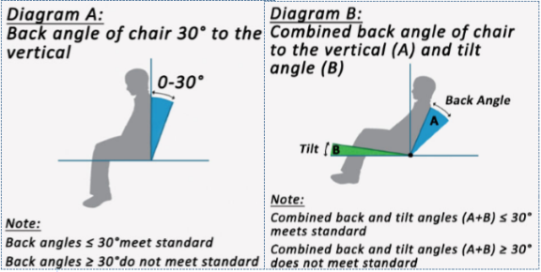 | YES | NO
Is the wheelchair adjusted to its lowest height for transport? | YES | NO
Do wheelchair modifications meet manufacturers’ recommendations for w/c securement and occupant restraint?  Note: If you are modifying the wheelchair beyond manufacturer spec, the manufacturer will not take any responsibility for any incidents that may occur | YES | NO

Please circle and indicate appropriate response below. Note: Any "No" responses may indicate a transport risk and risk of not meeting standards. Risks should be addressed as per the applicable risk assessment document of which your organisation uses prior to transportation and the person/NOK should be advised of the risks and these need to be documented in client’s notes. For any not applicable responses please state with reasons why.
Vehicle Considerations
Is the entry and egress in and out of the vehicle manageable and safe? |  |  |  | YES | NO
Will the person be in a forward-facing position in the  modified motor vehicle? |  |  |  | YES | NO
Vehicle Name/Type: |  |  | Vehicle Year of Manufacture:
What is the safe working load (SWL) of the existing or proposed loader (hoist/lift/ramp) on the vehicle: _____kg
Does occupied wheelchair weight fit within this SWL?  Refer to manufacturer’s manual/website for specifications. |  |  |  | YES | NO
Can this person be transported upright at all times with no need to change their current position in case of emergency e.g. seizure where the chair may need to be immediately reclined? If no, list condition and describe strategy.  Is there sufficient space in the vehicle to allow this to happen? |  |  |  | YES  YES | NO  NO
Wheelchair Tie down System (secures the wheelchair to the vehicle)
Does the Wheelchair Tie-Down and Occupant Restraint System (WTORS) comply with the appropriate standard? (Either AS/NZS 10542.1:2015, ISO 10542.1:2012, or AS/NZS 10542.1:2009) |  |  |  | YES | NO
Are all components of the wheelchair tie-down system in the vehicle clearly labelled with the manufacturer's name, month and year of manufacture and does the label state conformance to Australian or ISO Standard AS/NZS 10542.1:2015, AS/NZS 10542.1:2009, or ISO 10542.1:2012 (Specify type of system and details in notes). |  |  |  | YES | NO
Does the wheelchair tie-down system (in relation to a 4-point/6-point/Dock) match the manufacturer’s crash testing specifications for that wheelchair?  Refer to manufacturer’s crash testing documentation. Also note if there is additional requirement in the crash testing documentation that specifies for the WTORS to be within a specific safe weight limit |  |  |  | YES | NO
Is the WTORS compatible with the Securement System (e.g. Tracking/Click ‘n slide/Dock) in the vehicle?  Consult with Supplier if unsure and seek relevant documentation. |  |  |  | YES | NO
Are the wheelchair tiedown straps free from damage including nicks, tear, fraying, breaks etc. |  |  |  | YES | NO
The wheelchair tiedown system should also comply with the following:
When using a typical four-point wheelchair tie-down (see figures below), it is best to position the wheelchair so that the floor anchor points for the rear tie-down straps are directly behind the securement points on the wheelchair. A side-view angle of 30° to 45° relative to the horizontal is desirable. If possible, attach the front wheelchair tie-down straps to floor anchor points that are wider than the wheelchair to avoid interference with wheelchair foot supports and also increase lateral stability during vehicle movement. (International Best Practice Guidelines 2019/2020)
Note: If tiedown systems and tracking do not allow these angles to be achieved please indicate in notes what angles can be achieved as close as possible to the standard.
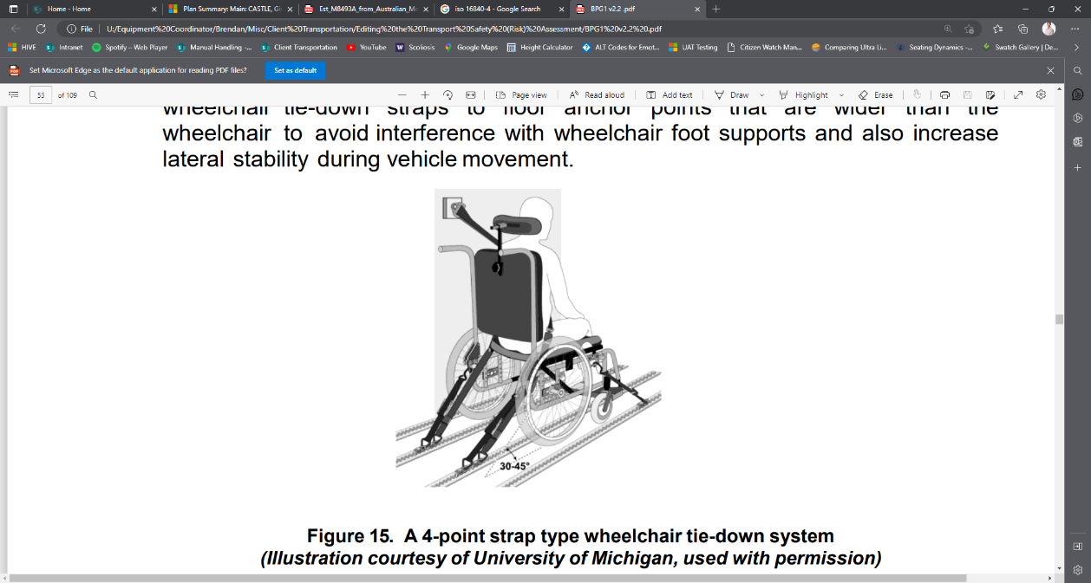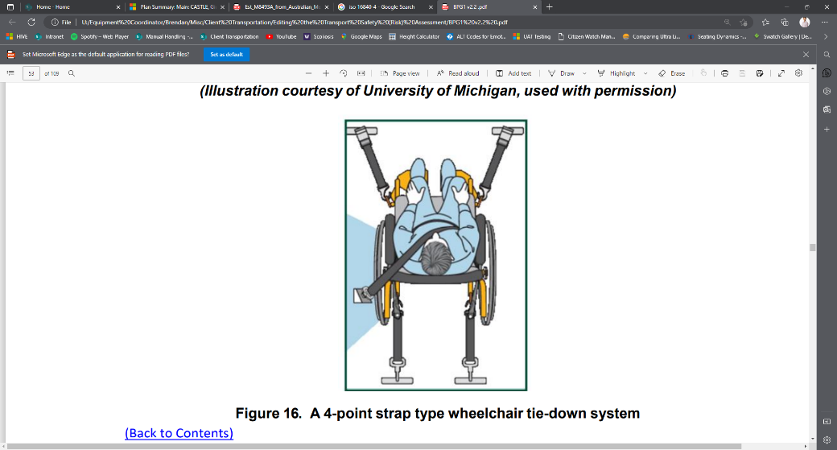
Images taken from International Best Practice Guidelines (BPG1 Transportationt of People Seated in Wheelchairs – 1st Revision 2019)

Front tiedowns can attach to the floor at an angle of 40° to 60° (relative to horizontal)  Left Tiedown Angle:  Right Tiedown Angle:  (Only if different) | 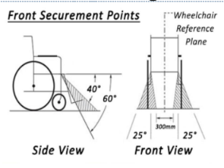 |  |  | YES | NO | Side projected view of front tie down straps between an angle of 40° and 60° from the horizontal and within 25° of the wheelchair reference plane; angled wider than the footplates, is best to provide some lateral stability to the wheelchair and to avoid interference with wheelchair footplates  *N.B.: if no what is the closest angle that can be achieved?
Rear tiedowns can attach to the floor at an angle of 30° to 45° (relative to horizontal)  Left Tiedown Angle:  Right Tiedown Angle:  (Only if different) | 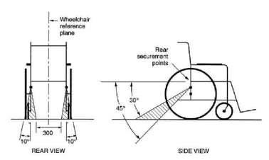 |  |  | YES | NO | Side projected view of the rear tiedown straps between angles of 30° and 45° from the horizontal and rear tie-down straps are directly behind the securement points on the wheelchair.  *N.B.: if no what is the closest angle that can be achieved?
Comments on Tiedowns:

Heavy and Powered Wheelchairs  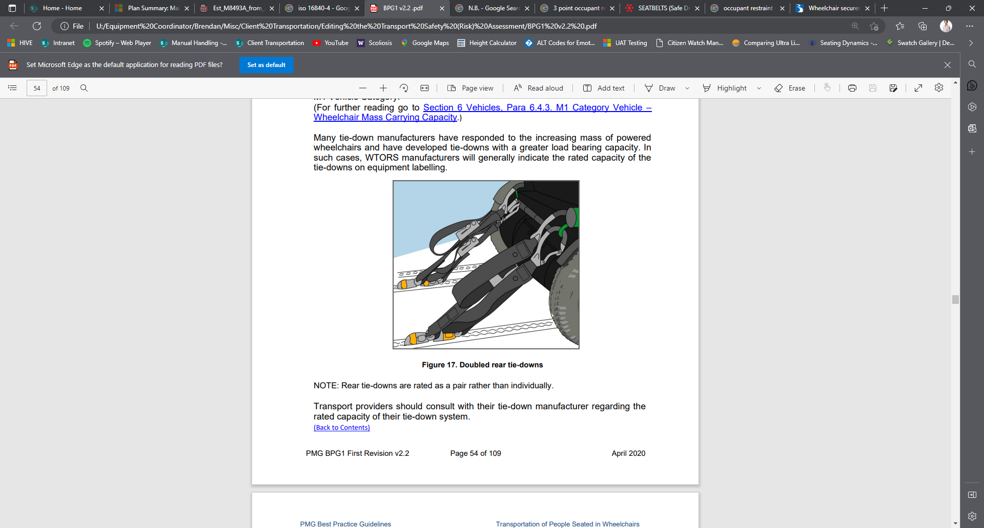 |  | - Powered Wheelchairs generally require 6-point wheelchair tie down systems with doubled rear tie-downs meaning 4 tie downs in total at the rear and 2 in front. (International Best Practice Guidelines 2019/2020)  - However, please refer to the wheelchair manufacturer’s guidelines on how many tie-downs to use and the correct location of tie-down points.
 |  | Does the client use a 6-point wheelchair tie down system? |  |  |  |  | YES | NO
 |  | If NO, should the client be using a 6-point wheelchair tie down system according to wheelchair manufacturer’s recommendations? |  |  |  |  | YES | NO | N/A
 |  | Comment/s:
Wheelchair Docking Systems  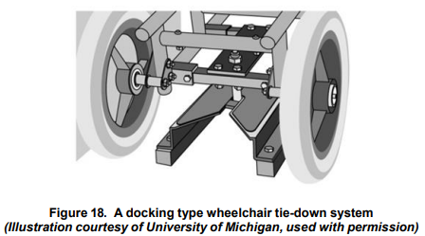  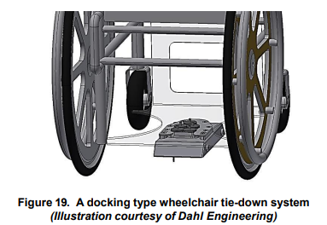 |  | - This system can be used in place of a 4-point of 6-point wheelchair tie-down system.  - Components on the wheelchair engage with a docking station mounted to the vehicle floor when the wheelchair is moved into position in the vehicle.  - Docking-type wheelchair tie-down systems are quick and easy to use, do not require manual effort, and may allow the wheelchair occupant to secure and release their wheelchair independently.  - However, there is a reduction of wheelchair ground clearance due to engagement hardware fitted to the underside of the wheelchair.
 |  | Does the client use a wheelchair docking system? |  |  |  |  | YES | NO
 |  | If yes, what is the name of the wheelchair docking system?
 |  | Has the wheelchair docking system been crash tested with the current wheelchair? |  |  |  |  | YES | NO
 |  | Comment/s:

Please circle and indicate appropriate response below. Note: Any "No" responses may indicate a transport risk and risk of not meeting standards. Risks should be addressed as per the applicable risk assessment document of which your organisation uses prior to transportation and the person/NOK should be advised of the risks and these need to be documented in client’s notes. For any not applicable responses please state with reasons why.
OCCUPANT RESTRAINT SYSTEM
Does the user have an Occupant Restraint System? |  |  | YES | NO
It is a requirement that the wheelchair user is secured to the vehicle with a dedicated occupant restraint system. Seating insert features such as a pelvic belt and/or chest harness do not qualify as an occupant restraint system as they do not secure the person appropriately to the vehicle if the vehicle suddenly accelerates or decelerates or is involved in a crash.
What kind of Occupant Restraint System is it?  If only a 2-point Occupant Restraint system is present, please provide comment/s regarding why. | (e.g. 3-point vs 2-point)
Comment/s:

3-Point Occupant Restraint Systems  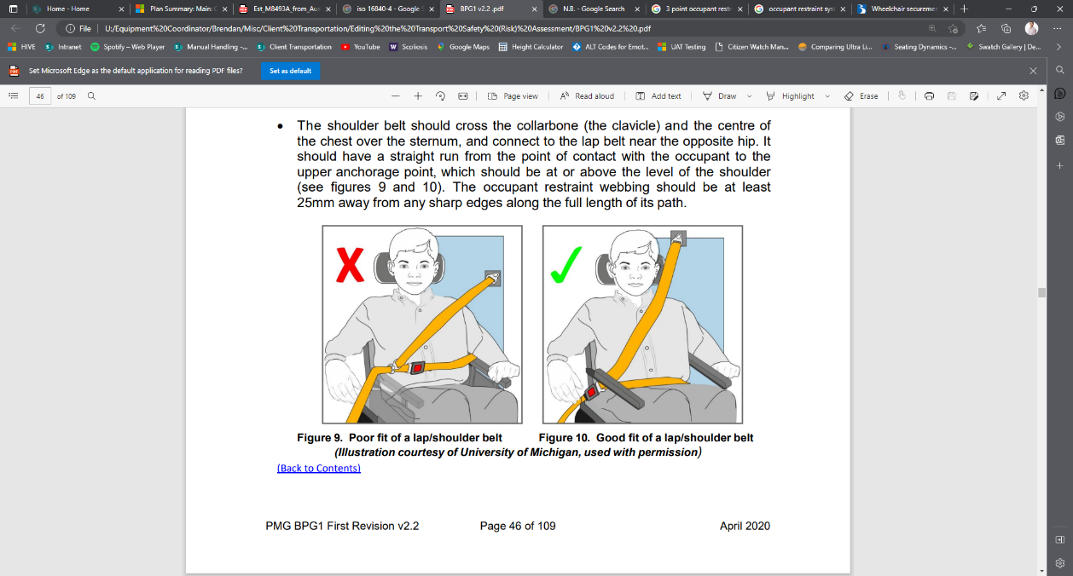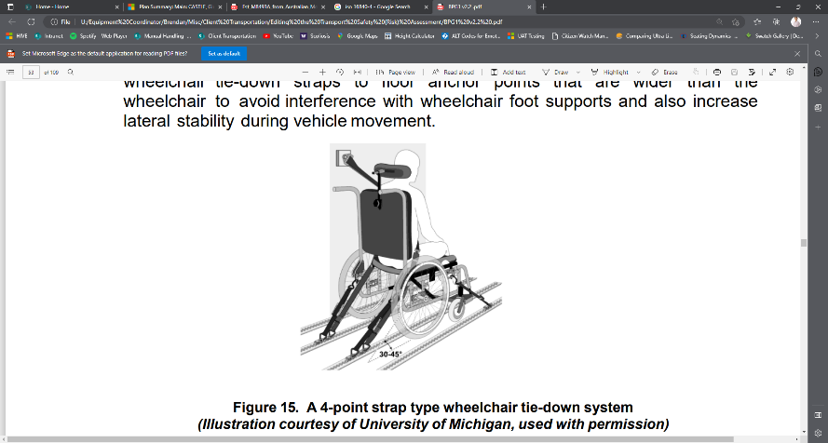 | 2-Point Occupant Restraint Systems  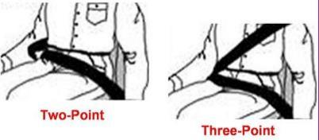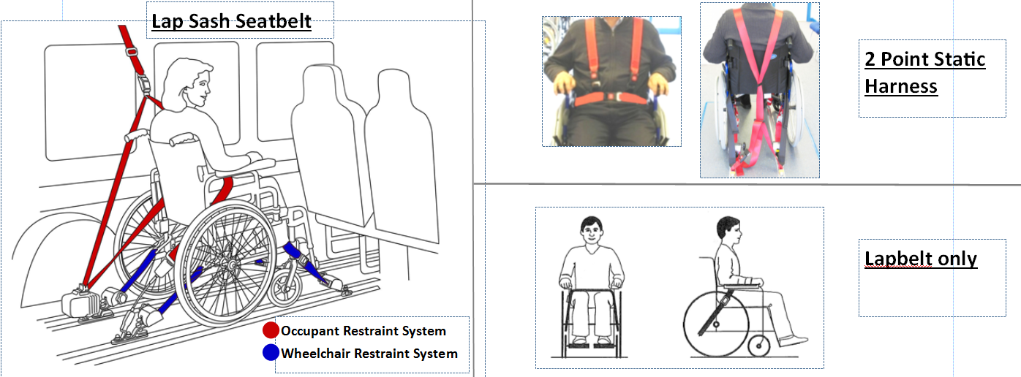
It is always recommended that a 3-point occupant restraint be used for wheelchair transportation. This is the safest option as per International Best Practice Guidelines, AS/NZS 10542.1:2015, and ISO 10542.1:2012.
- Currently there is no law in Western Australia which prohibits users seated in wheelchairs from being transported in a wheelchair accessible vehicle if only a 2-point occupant restraint is available. However, it is recommended that any vehicle or WTORS found to only have a 2-point occupant restraint be reviewed and investigated whether the vehicle and/or WTORS can be modified/upgraded to a 3-point occupant restraint. It is recommended that a 3-point occupant restraint be installed into the system/vehicle (if able) as soon as practicable. This is the safest option as per International Best Practice Guidelines, AS/NZS 10542.1:2015, and ISO 10542.1:2012.
- If continuing to use a 2-point occupant restraint system: clinical justification for this decision needs to clearly outline the reasons for continuting to use the 2-point occupant restraint and how the clinical benefits outweigh the risks associated – this needs to be documented.
- Regardless of whether using a 3-point or 2-point occupant restraint: please ensure the client also uses the chest/shoulder harness of their wheelchair seating insert if available. However, be aware that Seating Insert chest/shoulder harnesses are not crash tested devices and are not designed or rated to withstand forces of a motor vehicle accident – but they may provide a level of postural safety above not having any harness to secure the occupant’s torso.
The WTORS system should comply with the clear space requirements, stated in relevant section/s of AS/NZS 10542.1:2015 and International Best Practice Guidelines (2019) as per Figure 20:  - Rear clearance zone 450mm (and items in this zone covered with padding that conforms with the impact performance requirements).  - Minimum above head clearance zone 75mm.  - Front clear zone is 650mm with 3-point occupant restraint (lap and sash belt) and 950mm with 2-point occupant restraint (lap only belt).  - 220mm clearance zone on either side from midline of head.  Can this be achieved? YES NO N/A  (Clear zones are to ensure no contact of the head and body as well as to ensure that the necessary angles for the WTORS can be achieved)  If no, please explain in comments. |  | 950mm of front clearance is required if using a 2-point occupant restraint (pelvic/lap only).  650mm of front clearance is required if using a 3-point occupant restraint (lap + shoulder sash).  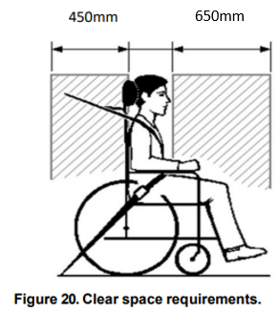  Above head clearance zone 75mm
Above Head Clearance:
Rear Clear Zone Distance:
Front Clear Zone Distance:
Left Clear Zone from Midline of Head:
Right Clear Zone from Midline of Head:
Comment/s:

Compliant Occupant Restraint Systems
- An ISO 10542-1 compliant wheelchair occupant restraint system is based on the 3-point system.
- The system anchors at three separate points in order to provide a lap section and diagonal shoulder belt for the wheelchair seated passenger.
- The pelvic or lap portion of the system anchors to structural regions of the vehicle, or to the wheelchair tie-down straps.
- The upper anchor point of the shoulder belt is attached to the structural points on the sidewall of the vehicle with the lower end of the shoulder belt connecting to the pelvic belt near the hip.

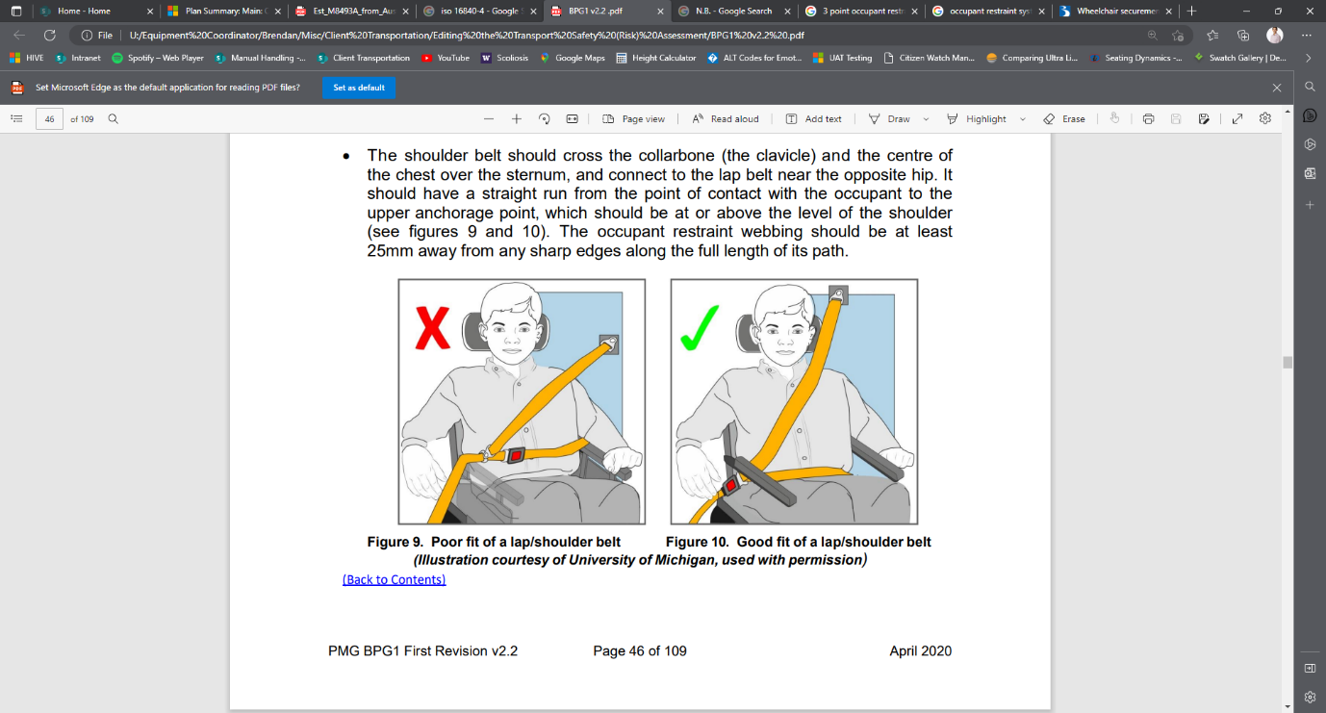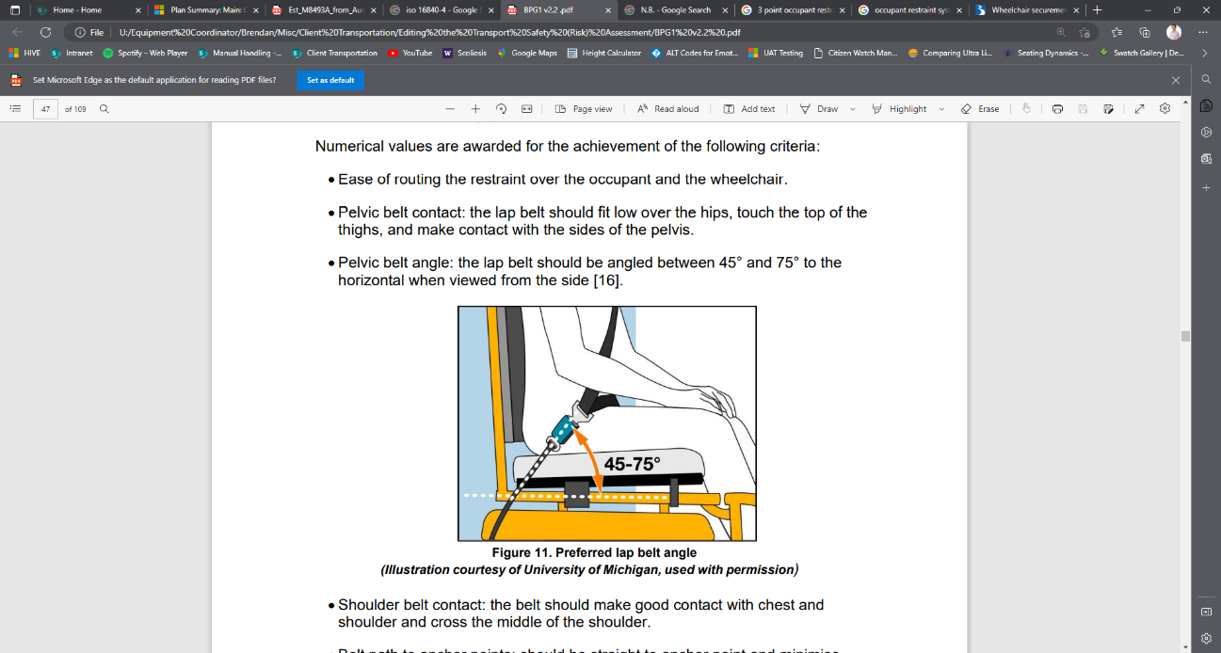

Occupant Restraint Path or Routing
- Lap belt section should lie low over the hips, touch the top of the thighs, and be angled between 45° and 75° to the horizontal when viewed from the side. Failure to create this steep angle of application is likely to allow ‘submarining’, resulting in pressure on the abdomen from the lap belt, and possibly leading to damage of internal organs in a crash event.
- Shoulder belt section should cross the collarbone and the centre of the chest over the sternum and connect to the lap belt near the opposite hip. It should have a straight run from the point of contact with the occupant to the upper anchorage point, which should be at or above the level of the shoulder.
- Some wheelchair hardware, such as arm supports, can interfere with good lap belt fit of vehicle anchored restraints by holding the belt away from the occupant resulting in submarining. Ensure occupant restraint is positioned correctly against the person’s body rather than over arm rests or postural supports.
- Occupant restraint should not come within 25mm of sharp edges that can cause tearing of the webbing.

Floor Anchored Shoulder Belts
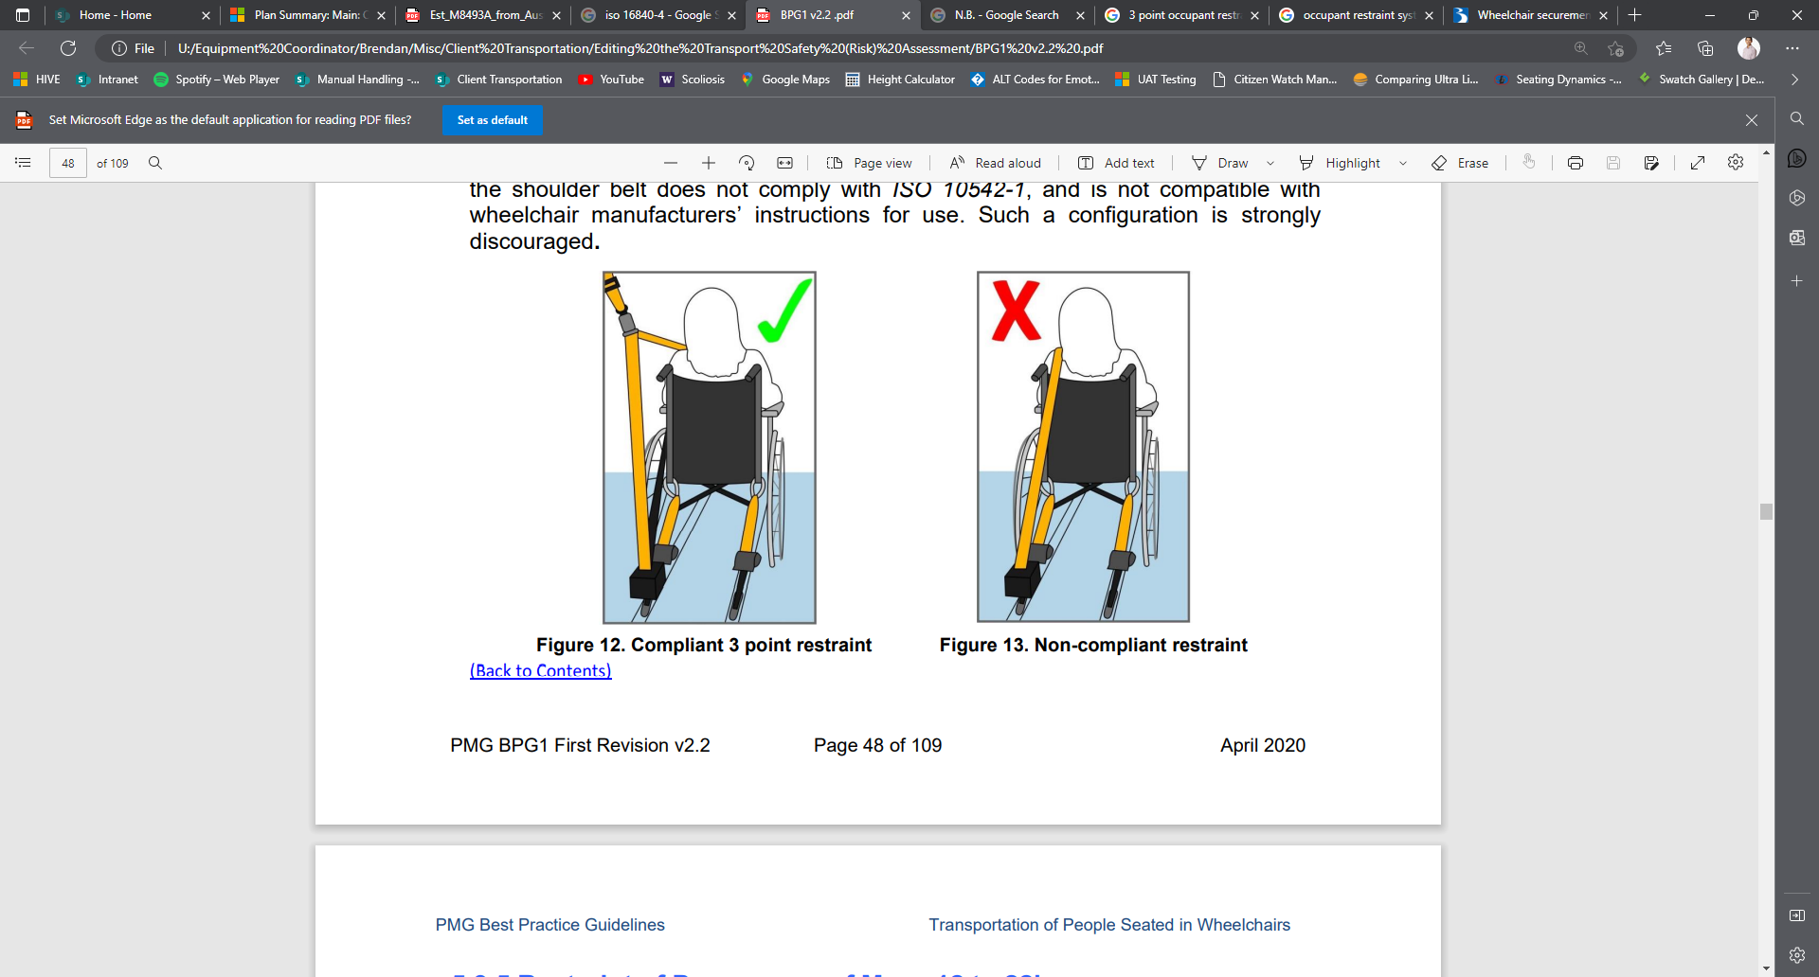
- In order to prevent spinal compression of the occupant, the effective anchorage for the upper torso restraint must be positioned above and behind the shoulder of the occupant.
- Anchoring the upper end of the shoulder belt to the floor has been shown to significantly increase harmful downward loading on the occupant’s torso and spine. An occupant restraint system with a direct to floor anchorage for the upper end of the shoulder belt does not comply with ISO 10542-1, and such a configuration is strongly discouraged.

Note: If postural support/seating system is used with a wheelchair there may be componentry that interferes with the correct lines of pull of the occupant restraint system. Please remediate as practicable and document reasons below:
Lap Belt Angle (Between 45°-75° to the horizontal is recommended):
Is the Shoulder Belt section safe? (E.g. does the Shoulder Belt section cross the collarbone and the centre of the chest over the sternum?) | Yes | No | N/A
Comment/s:

Note: Any behavioural considerations in terms of transport (e.g., client undoes seat belt, needs to be seated at the front of vehicle):
Note: Any medical conditions affected by transport (e.g., seizures by light, travel sickness—note strategies in transport plan):

Note: Consider growth and possible changes in mobility equipment (i.e., from MWC to PWC likely to affect vehicle transport clear space and securement, in the future):
Assessor Recommendations:

Assessor Name: | Profession/Role:
Organisation: | Phone:
Email Address:
Person/Guardian Declaration (Please circle appropriate response)
I (person/guardian) have been informed of the best practice safety standards and legislation in relation to me/my person being transported in my/their wheelchair; and understand where these have/have not been met. |  | YES | NO
Comment/s:
Person/Guardian Name:

Signature: | Date:
The following organisations were involved in the development of this document: Therapy Focus, Ace Therapy Services, Ability WA, Brightwater, Royal Perth Hospital, Fiona Stanley Hospital, Rehabilitation Technology Unit, Department of Communities, Rocky Bay, Senses, Indigo, Nulsen Group, SafeActions, Kids Are Kids, Mobility Engineering, Freedom Motors WA, Department of Transport WA.

